Course ___Methods_Test 3_ Year __12_______

Student name: ________________ Teacher name: ________________

Date:

Task type: Response

Time allowed for this task: _____45______ mins

Number of questions: _____9______

Materials required: Calculator with CAS capability (to be provided by the student)

Standard items: Pens (blue/black preferred), pencils (including coloured), sharpener, correction fluid/tape, eraser, ruler, highlighters

Special items: Drawing instruments, templates, notes on one unfolded sheet of
A4 paper, and up to three calculators approved for use in the WACE examinations

Marks available: __46____ marks

Task weighting: __10__%

Formula sheet provided: Yes

Note: All part questions worth more than 2 marks require working to obtain full marks.

Q1 (3.1.6) (3 & 3 = 6 marks)
Determine the exact gradient of each of the following at the given point. Show all working.
- at the point
Solution
Specific behaviours
diff
subs x value
obtains derivative

- at the point

Solution
Specific behaviours
diff
subs x value
obtains derivative

Q2 (3.1.6) (4 marks)
Determine the exact area shaded in the diagram below without the use of a classpad.
Solution
Specific behaviours
sets up integral
uses correct limits
shows antiderivatives
determines area

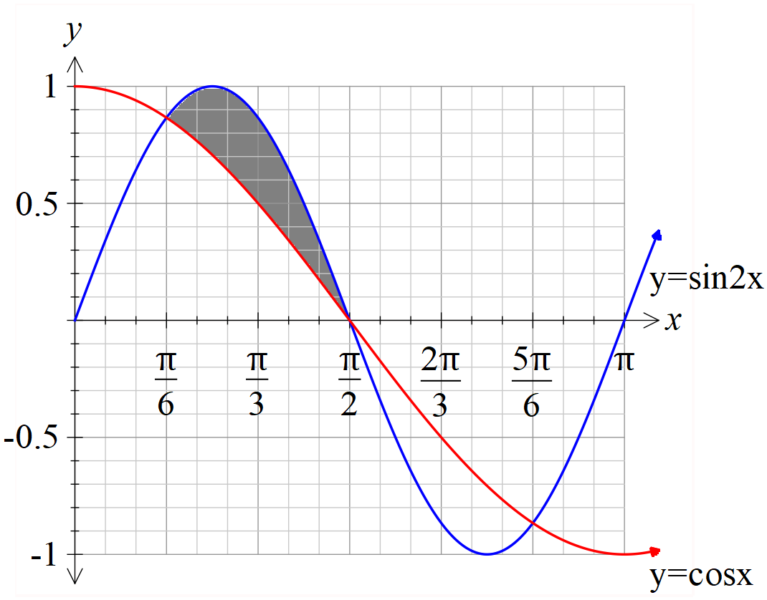

Q3 (3.1.6/3.1.10) (3 & 3 = 6 marks)
Consider the triangle drawn below with angle radians and fixed length sides 5 & 3 cm. Let represent the area of the triangle in .

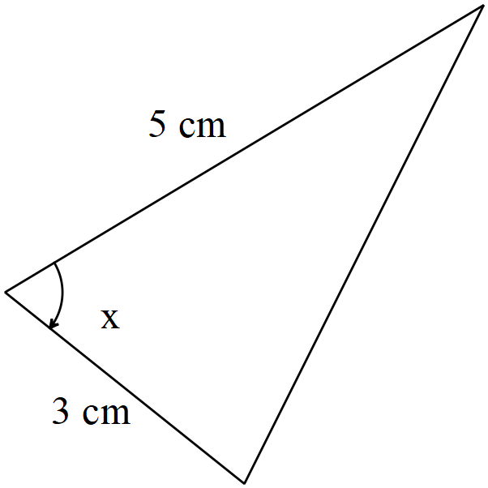
- Determine when .

Solution
Specific behaviours
uses area formula
states derivative
subs to find exact value or approx

- Using the increments formula, determine the approximate change in the area when the angle changes from to radians.

Solution
Specific behaviours
uses increments formula
subs correct values
determines approx. change

Q4 (3.3.1) (4 marks)
The expected value of the discrete probability distribution, given below, is . Determine the values of the constants and the variance of to 3 decimal places.
 | 1 | 2 | 3 | 4 | 5
 | 0.1 | P | 0.1 | q | 0.3

Solution
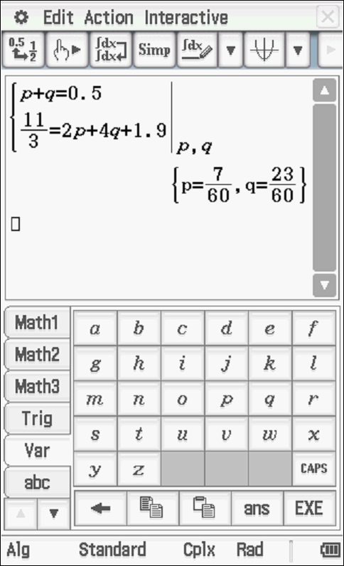

Variance =1.655

Specific behaviours
states one equation with p & q
states second equation with p&q
solves for p&q
states variance to 3 dp

Q5 (3.3.13) (3 marks)
A binomial distribution has a mean of 6 and a standard deviation pf 1.9. Determine the values of , the number of trials and the probability of a success.

Solution
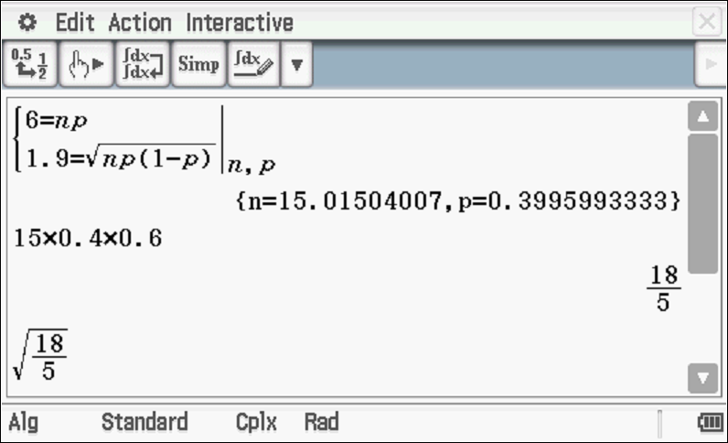
n = 15 & p=0.4
Specific behaviours
states two equations for n and p
solves approx. values
rounds n to an integer

Q6 (3.3.7) (4 marks)
A teacher needs to scale the results of her class by first multiplying be a constant and then adding a second constant. The original mean was 72 with a standard deviation of 21, the teacher needs the scaled results to have a mean of 60 and a standard deviation of 15. Determine the values of .

Solution
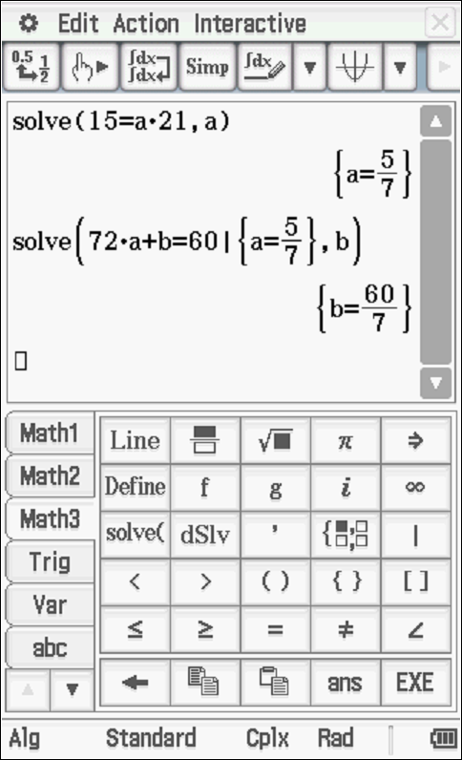

Specific behaviours
states one equation with constant
states two equations with constants
solves for one constant
solves for second constant
Q7 (4.1.11) (3 & 3 = 6 marks)
The displacement of a car moving in straight line is given by km at hours, where .

The following questions require full working and answers only given by the classpad will not receive full marks.

- Determine the velocity at hours.

Solution
Specific behaviours
uses product rule
diff log term
obtains speed

- Determine the time that the acceleration will be 0.2 .

Solution
Specific behaviours
shows how to diff velocity
sets up equation
solves for t

Q8 (4.1.6) (3 & 3 = 6 marks)
Consider the function .
- Sketch the function on the axes below showing all major features.
Solution
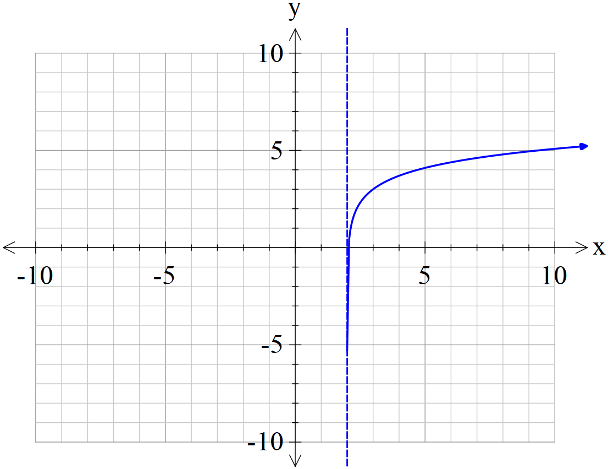

Specific behaviours
asymptote
shape
y less than 6 at x=10

- In terms of the constants , determine the x intercept of the function .

Solution
Specific behaviours
replaces x with x+2p
rearranges to an exponential equation
obtains expression for x

Q9 (4.1.11/3.2.16) (3 & 4 = 7 marks)
This question must be answered without the use of a classpad to receive full marks.

- (Simplify)

Solution
Specific behaviours
uses product rule
diff log term
obtains simplified expression

- Use the result from (a) above to determine in exact simplified form.
Solution
Specific behaviours
uses linearity principle (first line)
uses fundamental theorem
obtains antiderivative and subs correct limits
gives simplified exact log expression

